
Precision development
Deliverable #6

December 3, 2015
University of toronto scarborough
Authors: Brandon Chow, Daniel Persaud, Jason Zheng, Kenny Lam, Wilfred Wong
Table of Contents
State of Project 2
System Design 3
Testing Strategy 4
Test Approach 5
Unit Testing 6
Regression Testing 6
Acceptance Testing 6
Limitations 5
Example of test suite/validation strategy 5
Validation Strategy 6

Current State of the Project

As of December 3rd, 2015 our group has successfully implemented the following major features: batch tag editing, adding custom fields, coupling documents, and CSL editing. The functionality of each feature remains the same as in the previous deliverable, however, we have managed to work out all of the bugs that previous tests have identified. In addition, these features are all seamlessly integrated into Zotero and we have a completed testing plan outlined in the Testing Strategy section of this report that outlines what we would have done to rigorously test our plugin given ample time. Our user documentation at zotpie.readthedocs.org is still incomplete due to time constraints, however, we do plan on completing both the user documentation and developer documentation (at zotpie.rtfd.org/en/latest/index_dev.html) which will include everything a developer needs to know in order to use our code.

In addition to all of the above features, the standalone python batch editing and backup tools are ready to be packaged and released on GitHub for other developers to use on completion of the course. As in the previous deliverable, no changes were made to the product backlog and Story ID’s 6, 8, 9, 10, 11, and 12 remain untouched due to a lack of time.

*Note: The product backlog is included separately at ./product_backlog.pdf

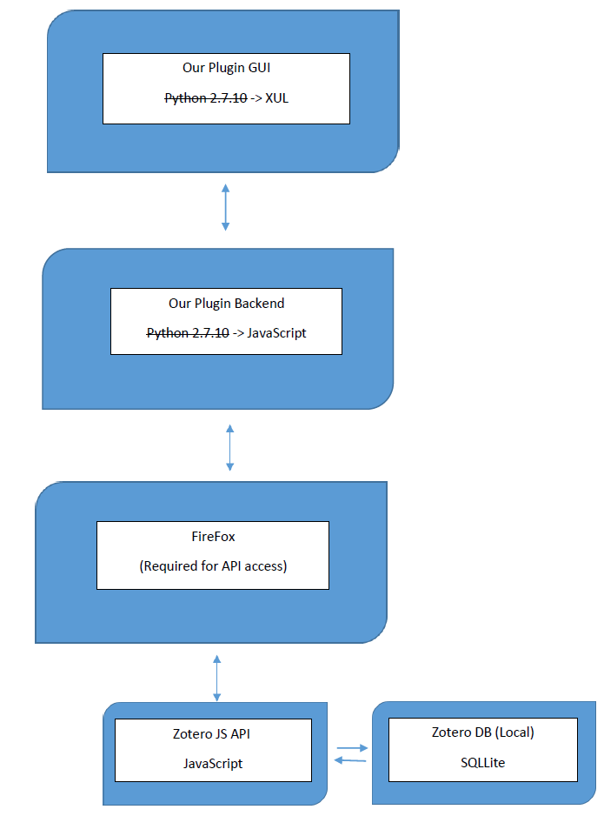
System Design

System Design Explanation:
- Our Plugin GUI uses XUL files to integrate with Zotero’s GUI, just as before the user will interact with this part of our plugin to perform tasks.
- Our Plugin Backend uses JavaScript to better interact with the JavaScript API provided by Zotero. It takes and processes input from the GUI and through firefox interacts with the JavaScript API.
- FireFox, needed to expose Zotero Internals (i.e. the JavaScript API) to our backend for use.
- Our Plugin uses the JavaScript API to allow our plugin to make changes locally. The Zotero Online DB will be updated with any changes made offline, or allow the user resolve any conflicts between the offline DB and the Online DB in a similar way to git or other version control systems (this is a built in Zotero function).
- The Local Zotero database (DB) is a SQLite database that Zotero Standalone/Firefox/Chrome uses to store all user data (through the JS API).

Testing Strategy

@remember to mention our meetings w/ natalie and the changes we made as paco said that was valid acceptance testing, emphasise the switch to JS

